

**Wireframe Documentation**

**Bike Share Prediction**



1. User can see below homepage when they come to the website

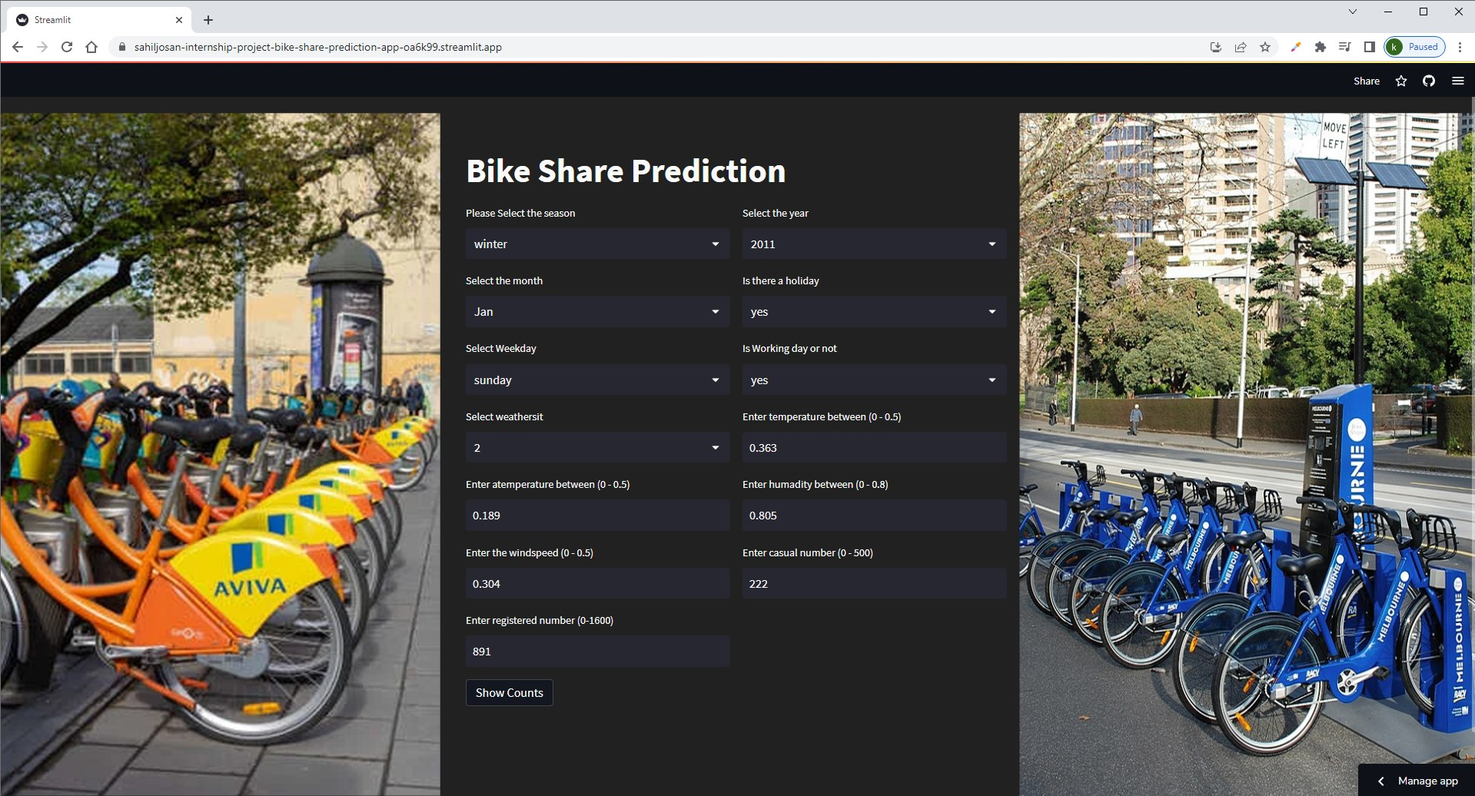



2. User can fill the form by selecting from the drag down menu.

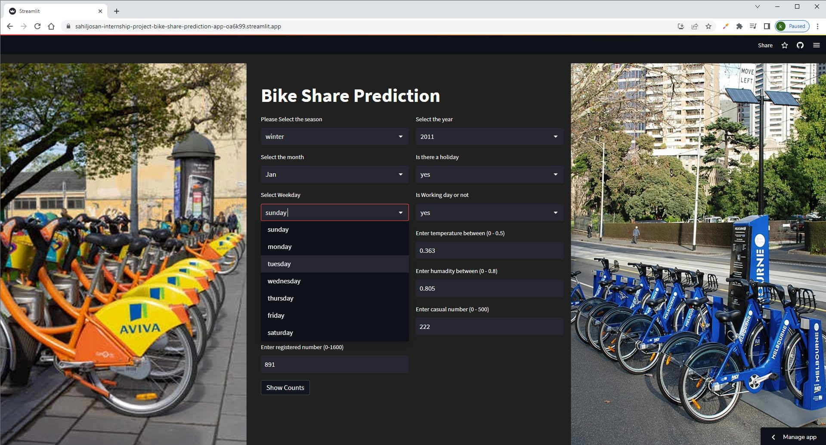



3. User can predict the count of rental bikes by clicking on the show counts button.

